Meta Title: TikTok Blocked in India (Again!) - Here’s What You Need to Know
Meta Description: Looks like the Indian government blocked TikTok again. Here’s why they did it, how they did it, and what you can do to unblock TikTok in India right now.

TikTok Blocked in India (Again!) - Here’s What You Need to Know
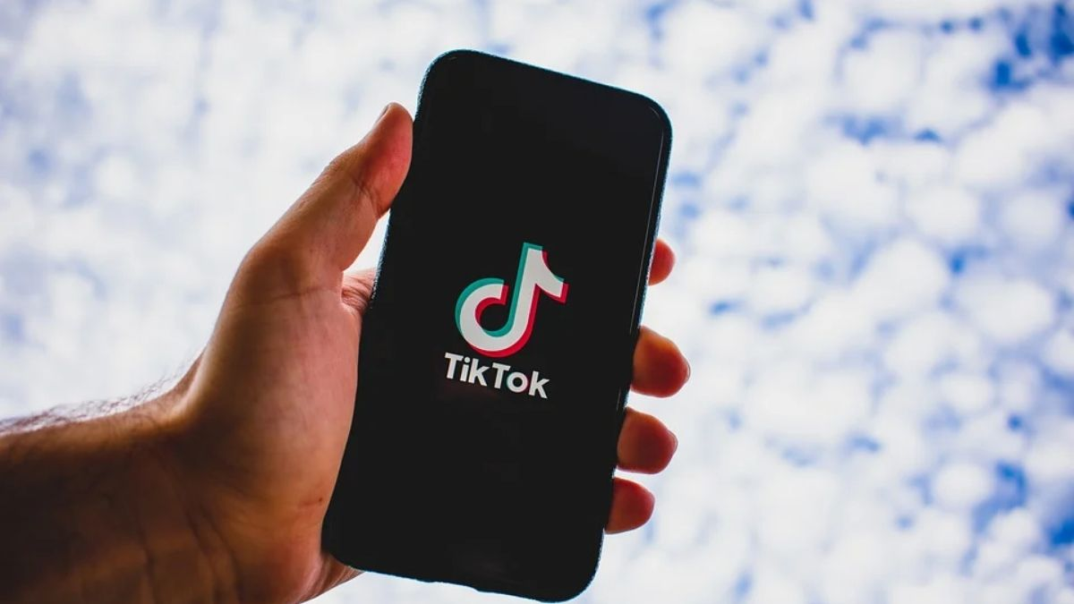
People in India were left with no access to TikTok overnight at the start of this month. The government apparently ordered Indian ISPs to block the app (and 58 other services) because it poses a “security threat.”
Wait, what? TikTok? A security risk?
Sounds pretty weird, right?
Not if you consider the context – the deadly border clash that took place between India and China last month, in which 20 Indian soldiers lost their lives.
The Indian government responded by fortifying its border, and also blocking 59 Chinese apps in the country (one of which is TikTok).
Why bother blocking the apps? It’s not because they’re “security threats,” but because the government harms the Chinese companies’ revenue that way. TikTok alone has over 200 million users and roughly 2,000 employees in India. If the app doesn’t work in the country, the company behind it (ByteDance) loses a lot of money.

This Isn’t the First Time This Happens
TikTok had problems with the Indian government back in 2019 too. Apparently, a court ruled the app could expose children to “inappropriate content.”
So the government forced ISPs to block the app for a week. Granted, it wasn’t as bad as now. Users who already had TikTok installed on their smartphones could still use the app.
Even so, the one-week block was a huge blow to ByteDance. They reported losing around $500,000 per day, and many people risked losing their jobs. Also, they almost lost the opportunity to expand into one of the fastest growing markets in the world.

How Does the TikTok Ban Actually Work?
Initially, Apple and Google said the Indian government asked them to remove the TikTok app from their stores. They didn’t do that, obviously, but TikTok voluntarily delisted its app from the Indian app stores.
Eventually, the government ordered Indian ISPs to block connections to TikTok servers. There’s a chance they might block app store download links if the app becomes available for download in India again.
So basically, the Indian government is using a firewall (much like China does with its Great Firewall) to stop Indian users from using TikTok.
Right now, if you’re in India and try to use the TikTok app or access its site, you’ll see a message like this one:
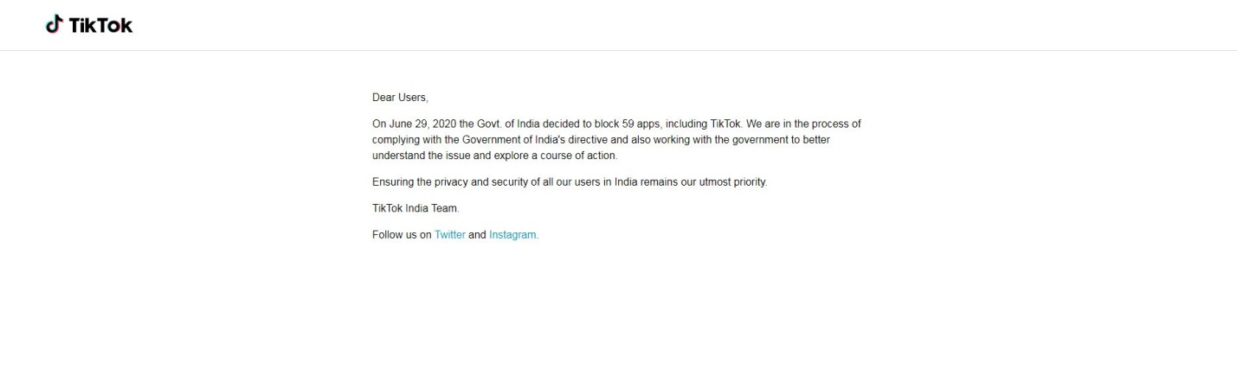

Can You Unblock TikTok in India Right Now?
Some people would just tell you to wait out the ban since it might be over soon.
Why put up with that, though? If you’re a big influencer and have thousands of fans worldwide, you can’t really put them on hold. Or maybe you just like using TikTok to have fun with your family and friends who are abroad.
Well, we have good news – you can successfully unblock TikTok in India. You just need to use a VPN. If you’re not sure what that is, it’s an online service that hides your IP address and encrypts your traffic.
The “hiding your IP address” will be of interest to you in this case. It’s how you can bypass firewalls, after all. Here’s how it works:
- You use a VPN app to connect to a VPN server.
- The connection to the server goes through your ISP’s network.
- Once connected, you use TikTok.
- Your smartphone will send a connection request to TikTok’s servers.
- The request goes through your ISP’s network and the VPN server. The server intercepts it and forwards it to TikTok’s servers.
- Due to that, TikTok will only interact with the VPN server’s IP address, not your IP address. And the server’s address doesn’t have any firewall restrictions linked to it like your address does.
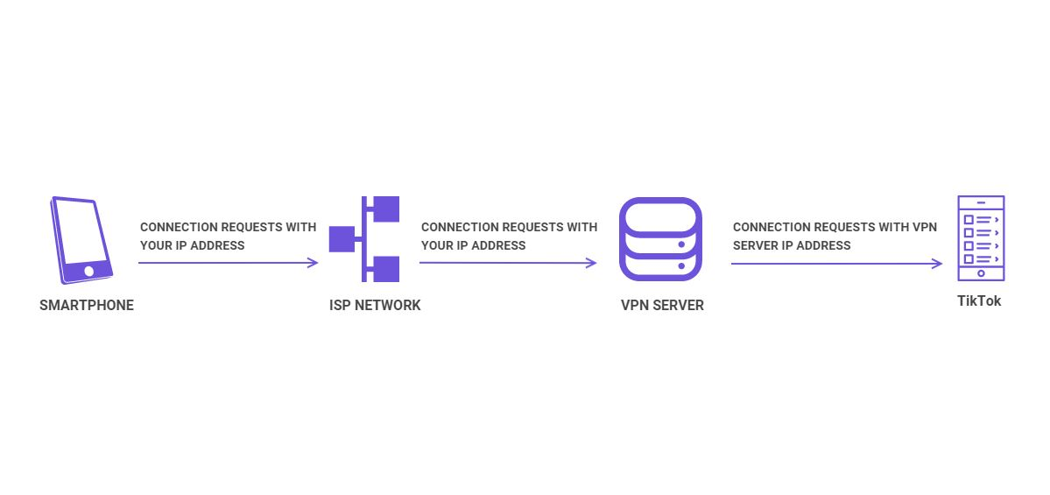
Similarly, you can use a VPN to download TikTok from the app store. Just connect to a VPN server in another country, and access iTunes or Google Play. The app stores will see a request coming from the VPN server that has a non-Indian IP address.
So, they’ll whitelist your access to TikTok, and you’ll be able to download it.
And that’s not all. A VPN will also hide the fact that you’re unblocking TikTok in India. Here’s why:
- Your ISP will only see your connection to the VPN server. They won’t know you’re actually connecting to TikTok’s website, servers, or app store download pages.
- The VPN encrypts all your traffic between your smartphone and the VPN server. Your ISP won’t be able to monitor your data packets anymore to see what web apps you use.

How to Find the Best VPN for the Job
Unfortunately, not all VPNs can successfully unblock TikTok in India. The government can force ISPs to blacklist VPN server IP addresses, stopping you from connecting to them.
So, you need a VPN that refreshes its IP addresses on a regular basis, has hundreds (if not thousands) of servers to choose from, and offers smooth and stable speeds.
The ability to use the IKEv2 protocol is also a must since it’s excellent for smartphone users. It has a feature that stops the VPN connection from dropping when you switch from a WiFi network to mobile data, and vice-versa.
Unfortunately, even with all that information, you still might have a hard time finding a really good VPN. There are hundreds of them on the market, after all.
Don’t worry, though – there’s actually a simple shortcut that saves you tons of time and effort. And we’ll share it with you right now: ProPrivacy’s ultimate guide to the best VPNs for TikTok.
It has all the information you need to find the right service for you. Plus, all that content is presented in a very reader-friendly and easy-to-scan format.

What’s Your Opinion on TikTok Being Blocked in India?
Did the Indian government make a mistake, or was their decision justified? Go ahead and share your thoughts with us in the comments or on social media.
Also, if you know other ways to unblock TikTok in India, tell us about them.

